**Name**: Mostafa Yousry Abd-rabouh Shaheen

**B.N**: 942

**Date**: 20/5/2020

**Topic**: Artificial Intelligence

**Artificial Intelligence:**

The ability to perform tasks typically connected to intelligent beings, such as artificial intelligence (AI), a digital computer or computerized robot. This concept is also applied to the project of designing structures that are characteristic of human intellectual processes such as perception, meaning exploration, generalization, or learning from the past. It has been shown, ever since digital computer development in the 1940s, that computers can be programmed with great skill to perform very complicated tasks, such as finding proof of mathematical theorems or playing chess.

Nevertheless, there are no systems yet that equal human versatility in wider domains and in tasks that require comprehensive daily expertise given the ongoing improvements on computational processing speed and memory power. On the other hand, some programs have gathered the level of performance of human experts and experts in carrying out certain tasks so that in applications as diverse as medical diagnosis, computer search engines and speech or handwriting accuracy artificial intelligence in this limited sense is found.

**Screenshots:**

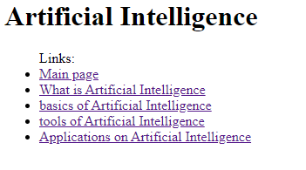

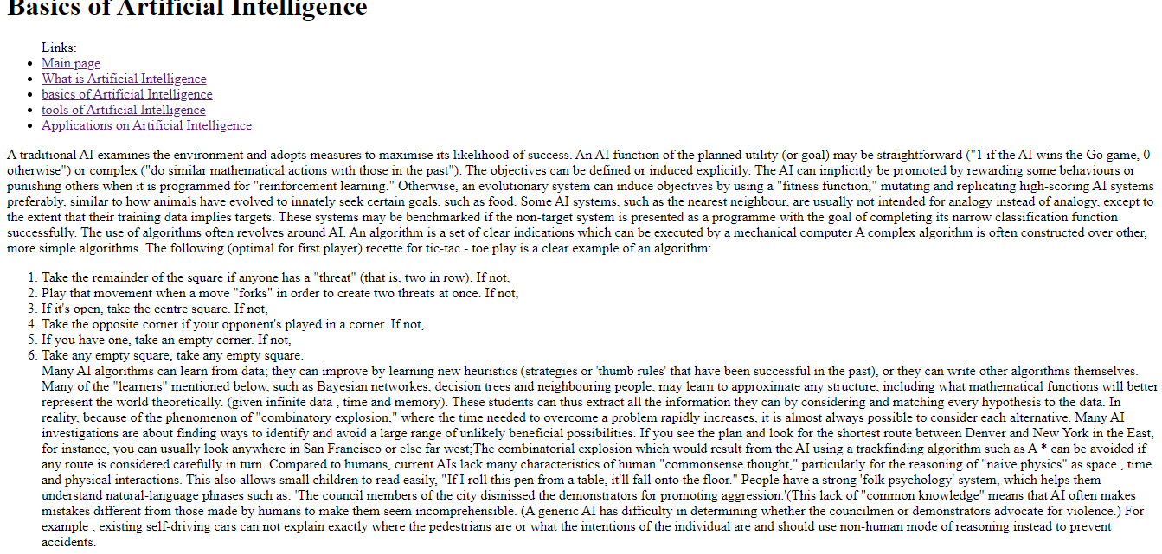

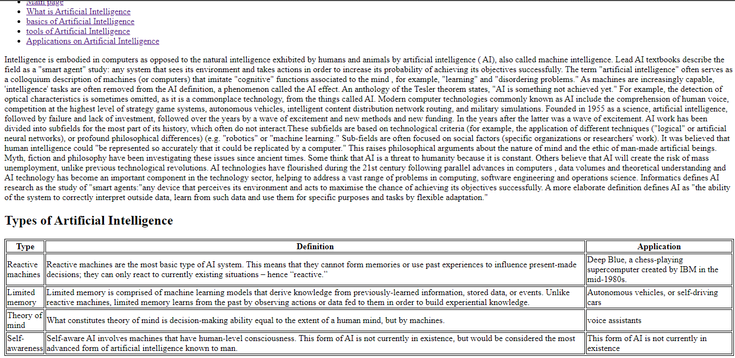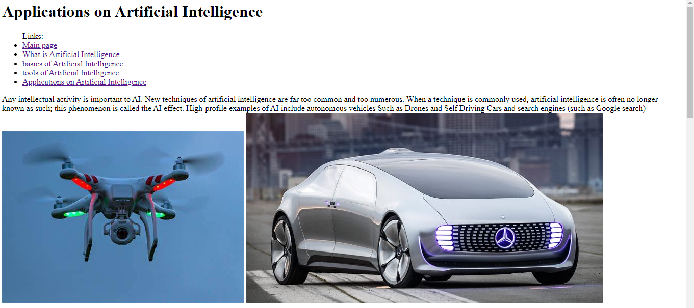

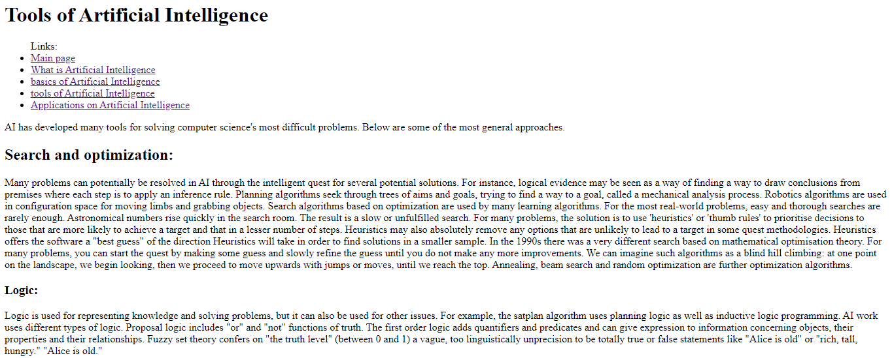

**Source code:**

